Propagate Temperature time series to Depth (PT2Z) script [READme]

Introduction

The “Propagate Temperature time series to Depth” (PT2Z) scripts allows the user to propagate a temperature time series through mediums of differing thermal properties to depths defined by the user. This is done by solving (Fourier, 1882) thermal diffusion equation1-4,6 (eq.3). Often this method is used to remove the annual ambient Ocean Bottom Temperature (OBT) signal from a temperature profile - time series taken within shallow (0-10m) ocean bottom sediments2-4. In shallow seas e.g. (North Sea or Baltic) the seasonal variation could be as high as 18k and their residuals propagate to a depth of 10m7. Removing the ambient annual “noise” signal improves the derived geothermal gradient estimate, which is used in basin evolution modelling2,4. Another use includes modelling the thermal suitability of marine sediments for submarine high voltage cables5-7. Large ambient (OBT) fluctuations at the depth of a buried cable may inform design and route in the predesign phase which aims to keep the cable as cool as possible.

Equation and behaviour

To model the seasonal (OBT) variation the 1d heat transfer equation:

(1)

$$∂T\left(Z,t\right)-k∂^{2}T\left(Z,t\right)= 0$$

Is solved with temperature T(Z,t) as a function of depth (z) and time (t) for homogenous sediments with thermal diffusivity (k) and annual variation:

(2)

T(Z=0,t) = Tmean + TDCos($ωt+φ)$

(Eq.2) is a simplified sinusoidal boundary condition for the surface (Z = 0m). The sediment will act as a low pass filter, high frequency – low order (semi-diurnal) variations can be neglected. And higher order lower frequency (annual) signal can be modelled with the solution as follows:

(3)

$$T\left(z,t\right)= T_{mean}+\frac{dT}{dz}.z+T_{D}{.e}^{(-\sqrt{-\frac{ω}{\left(2k\right)z}}.cos(ωt-\sqrt{\frac{ω}{2k*z}}+φ)}$$

T(Z,t) : Temperature at depths (Z) and times (t)

Tmean ­: Mean annual temperature

$\frac{dT}{dz}$: The Geothermal gradient (K/m)

TD : Amplitude of annual variation

$ω$: Angular frequency (In this case $ω= \frac{2Π}{365}$)

$k$: Thermal diffusivity (m2s-1)

: Annual phase shift

The script

As well as calculating T(z,t) the individual functions sort, process and generate common outputs which have been useful in past projects. The script as a whole is designed to make this process easier and more user friendly.

<Section> Functions List:

PT2Z_1_Propagate_Temp_To_DepthZ_ManualInput_Master.m

<S1> Pretty_Figures.m

<S2> PT2Z_2_ProcessOBT_Data.m

<S3> PT2Z_3_AutoFill_PT2Z_4.m

<S4> PT2Z_4_Gen_Annual_Input_Sinusoid.m

<S5> PT2Z_5_Extract_T_at_Z_to_Table.m

<S6> PT2Z_6_Temp_To_DepthZ_Figure.m

<S7> PT2Z_7_Temp_vs_Depth_At_times_t_Figure.m

Script design – Sections and functions:

Some (PT2Z) functions are irrelevant depending on the desired outputs and some are dependent on the outputs of previous functions (figure.1). For ease of use, all functions should be ran section-wise from the PT2Z_1 Master script. PT2Z_1 is split into 7 sections corresponding to the 7 included functions. A section is defined on its first line by the ‘%%’ syntax then followed by its title e.g. ‘%% Section 1’. Clicking inside each section will result in the section highlighting yellow. After defining any inputs to that section and ensuring the section is highlighted, press “Run Section” or (Ctrl + Enter) to run that section. Referring to (figure.1) and running PT2Z_1 section-wise will ensure the data flow from previous functions and the manual inputs to subsequent sections are easier to follow.

Figure.1) The section dependencies of PT2Z_1 Master Script. Section 1 <S1> is optional and need only be ran if you want figures to look good – it is recommended you run <S1>. Likewise <S2> and <S3> are optional and only required if you have an (OBT) time series. <S4> is the only essential function which generates the input data for <S5>, <S6> and <S7>. <S4> can be automatically fed inputs from <S3> if you have an OBT time series, otherwise you can manually add the inputs. <S5>, <S6> and <S7> need only be ran if their individual function / outputs are required.

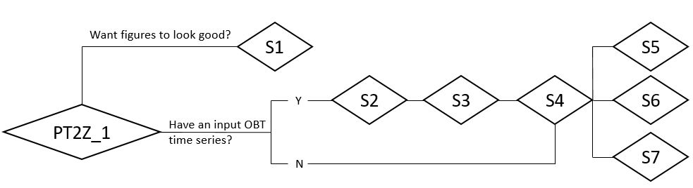

Sections in detail

<S1> Pretty_Figures

Figure.2) Section 1 of PT2Z_1. Running this section runs Pretty_Figures.m which can be found in the current folder. This .m file contains a list of defaults which can be set to make figures look better.

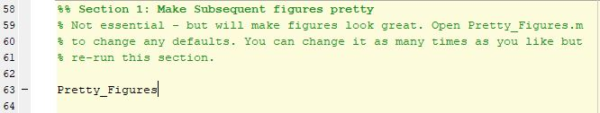

<S1> is optional and makes any subsequent figures look better than the default.

Running <S1> runs Pretty_Figures.m which can be found in the current folder. Pretty_Figures.m contains a short script of figure settings which can be changed to the user’s preferences. Re-running <S1> will update any changes to these setting and will be visible on any subsequent plots. Some preferable defaults have been set in Pretty_Figures.m so it’s recommended you just run <S1> regardless of any changes to Pretty_Figure.m.

<S2> PT2Z_2 ProcessOBT_Data.m

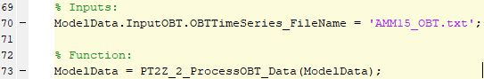

Figure.3) Section 2 of PT2Z_1. After defining [line 70], running section 2 runs the function PT2Z_2_ProcessOBT_Data.m.

<S2> is optional and should only be used if there is an ambient (OBT) time series (figure.1).

An ambient (OBT) time series should be in the format of the example given “AMM15_OBT.txt”. This dataset can be generated for different locations by following the instructions in ‘Gen_Daily_OBT_ts’. Once [line 70], the filename of the (OBT) data is defined run <S2> to run the function PT2Z_2_ProcessOBT_Data.m which sorts the ambient (OBT) data into the available years, producing the first figure (figure.4).

By running <S2> an output folder is generated within the current folder called “Propagate_Temp_To_Depth_Z_OutputFolder+[CurrentDate]” and within this, another folder called “Figures” is generated. (Figure.4) is automatically saved to this folder with the name e.g.“ PT2Z_2_[Model Used]_OBT_Options.jpeg”.

Figure.4) The figure output from <S2>; processed AMM15_OBT.txt ambient (OBT) shows data spanning five years [2016-2020]. Only 3 (2017; 2018; and 2019) are whole years, in fact 2016 only has 1 data point. Only 2017 and 2018 look like you’d expect (almost perfect sinusoids). Either 2017 or 2019 are examples of preferable choices of ambient input (OBT). This is good to know for <S3>.

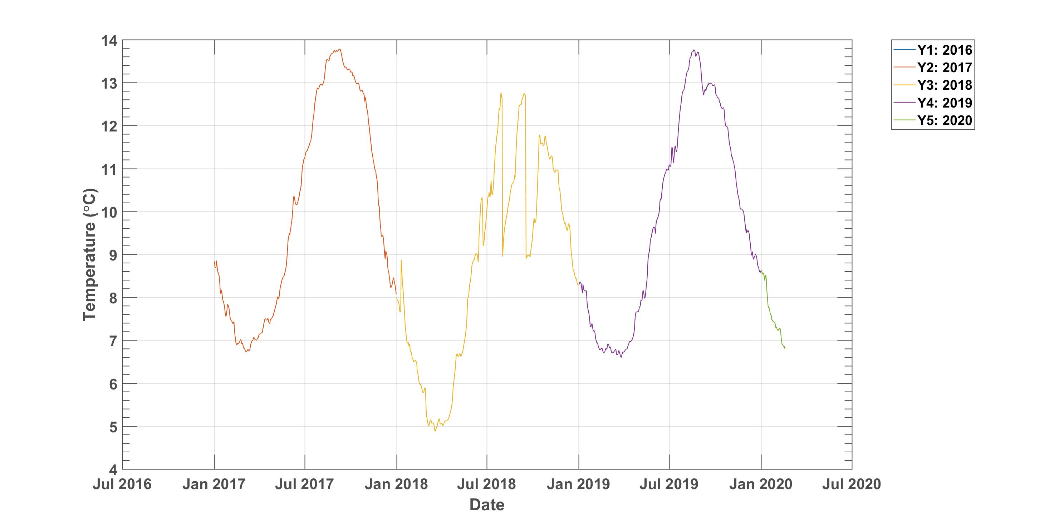

<S3> PT2Z_3_AutoFill_PT2Z_4.m

Figure.5) Section 3 of PT2Z_1. <S3> requires you define Y which is the choice of year from section 2 where Y = the year of the years available in the order it appears in the legend i.e. 2017 = 2 (figure.4).

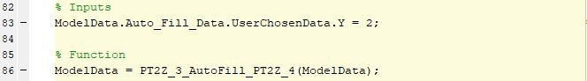

<S3> is optional and should only be used if: (1) there is an ambient OBT time series and (2) <S2> has been ran (figure.1).

<S3> requires Y [line 83] (figure.5) be defined as the desired years position in the legend of (figure.4) i.e. for 2017, Y = 2. Running <S3> runs the PT2Z_3_AutoFill_PT2Z_4.m function which uses the annual (OBT) defined by Y to derive a number of variables required in <S4>. The derivable variables will be printed to the command window (figure.6) and can be used as auto inputs to the corresponding variables in <S4> by ensuring the flag on <S4> [line 116] is active or equal to one.

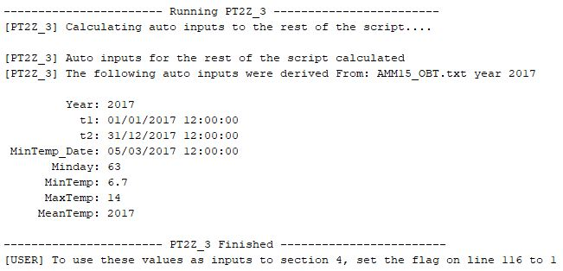

Figure.6) The output from <S3> is printed to the command window and includes variables in <S4> which can be derived automatically by processing an input (OBT) time series. In this example the 2017 year of AMM15_OBT.txt.

<S4> PT2Z_4_Gen_Annual_Input_Sinusoid

<S4> has 12 mandatory inputs. The first 7 (figure.7) must be manually input, the remaining 5 (figure.8) can be auto filled as the outputs from <S3> if you have an input OBT time series or manually input.

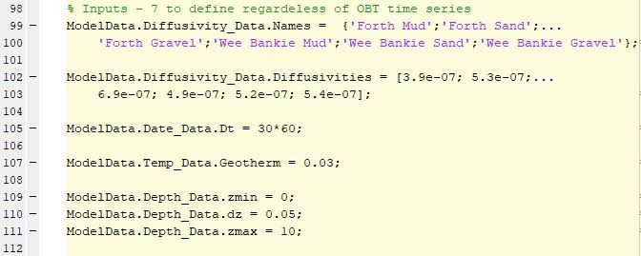

Figure.7) Section 4 of PT2Z_1 Master script. Are manual inputs to section 4 regardless of OBT time series.

<S4> [line 99] defines the diffusivity names, this could be e.g. (formations or locations). The script takes names in the syntax of a “cell array”. In the example (figure.7) 6 formation names are given. You can provide as many names as required but they must be in the form of a cell array i.e. {‘Name1’;’Name2’,’NameN’} essentially {‘NameN’;}.

<S4> [line 102] defines diffusivities (m2S-1 ) corresponding to the formation names provided. As many diffusivities as required can be defined however these must be in the form [diff1; diff2; diff3], essentially [diffn,] and there must be the same number of diffusivities to diffusivity names.

<S4> [line 105] defines the time step in dt in seconds at which the T(tmin:dt:tmax) data will be modelled e.g.(30*60 = .5hrly time steps).

<S4> [line 107] defines the steady state geotherm – in the example 0.03 k/m is given which represents the global average.

<S4> [lines 109-111] define the depth range zmin, zmax and the depth step dz. In the example case zmin = 0, dz = 0.05 and zmax = 10 so T(zmin:dZ:zmax : tmin:dt:tmax) will be calculated z = 0, 0.05, 0.1, 0.15…. 10.

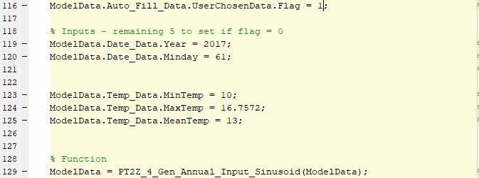

Section 8) Section 4 of PT2Z_1 Master Script. The remaining 5 inputs (lines 119-125) can be defined automatically as the outputs from <S3> by setting the flag on line 116 to 1. If there is no annual input OBT, set the flag to 0 and define the inputs manually.

<S4> [line 116] defines a flag which can have values of 1 or 0. 1 should be chosen when: (1) there is an input (OBT) time series which (2) you have ran through <S1> and <S2> and (3) you wish to use the output to autofill the inputs to [lines 119 – 125]. A flag value of 1 will also plot the input (OBT) time series onto subsequently plots. A flag value of 0 should be defined if there is no input sinusoid and the user should manually define [lines 119-125].

<S4> [line 119] defines the year you want to generate an OBT input sinusoid for in the format YYYY.

<S4> [line 120] defines the “minday” or the day the minimum temperature was recorded. In this case 61 would be the 2/03/2017 or the 61st day of the year.

<S4> [line 123 – 125] define temperature data, the minTemp maxTemp and MeanTemp of the annual time series data.

After [lines 99-125] are defined, running (Section 4) runs the PT2Z_4_Gen_Annual_Input_Sinusoid.m function. The PT2Z_4 function generates an annual idealised input (OBT) at Z = 0 e.g.(“Generated OBT for 2017” (figure.9)). This idealised (OBT) is propagated through mediums of diffusivities at the depth and the time ranges defined in <S4>.

NB: you can track its progress by watching the command window. Each function will tell you what it is doing as it is doing it, and when it has finished and what it has output.

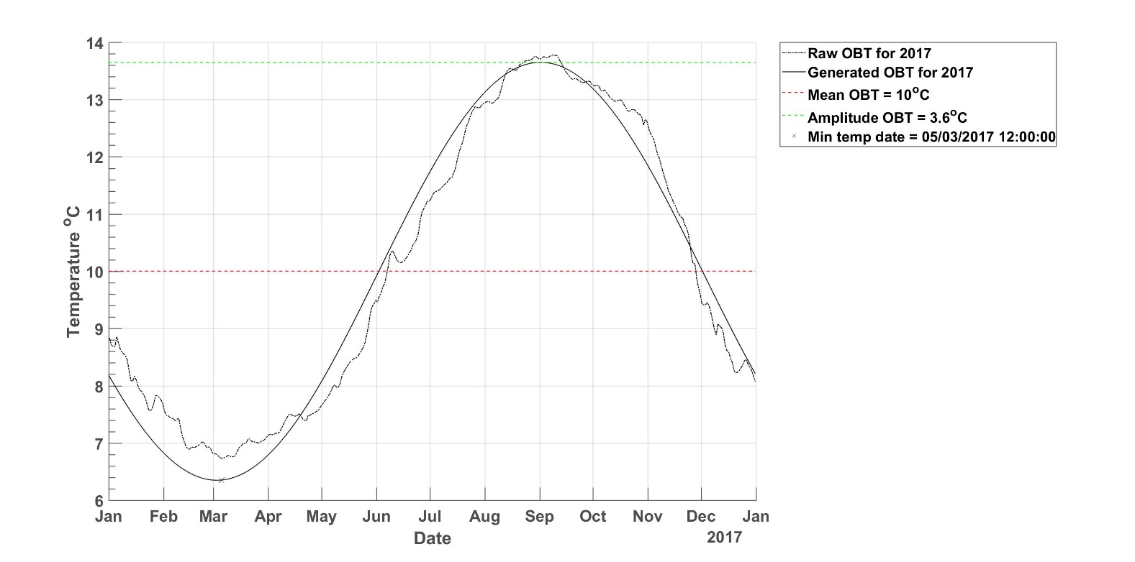Figure.9) As well as generating all the T(z,t) data, <S4> outputs (figure.9) showing the generated idealised sinusoid “Generated OBT for 2017” and important input parameters (mean, amplitude and min temp date) of the generated sinusoid. Additionally in the <S4> example the auto input flag on line 116 is on 1, this uses the output of <S3> as the inputs to <S4> and plots the “Raw OBT” for the year chosen. Again this figure is saved in the “figures” folder automatically.

<S5> PT2Z_5_Extract_T_at_Z_to_Table

Figure.10) Section 5 of the PT2Z_1 Master script. <S5> requires two inputs on [lines 144 and 146].

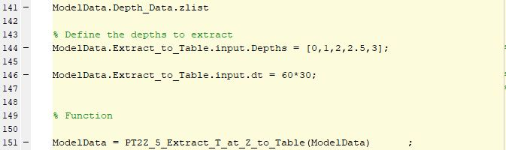

<S5> extracts the temperature for the whole time series at the depths defined by the user T(Zi,t) for each diffusivity provided (figure.11). The result is extracted to a .txt folder which can be imported into e.g. excel.

<S5>has 2 mandatory inputs [lines 144 and 146]. [Line 144] requires the depths of interest be defined. The depth values must have been calculated i.e. (within the zmin:dz:zmax) range defined in <S4>, to check you can run [line 141] to see the full list of depths.

<S5> [line 146] is required to be defined as the time step the of the output table. If this is different to the one in <S4> the script will interpolate to the new time step.

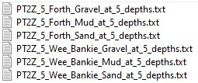

Figure.11) The output to <S5> is stored in the “PT2Z_5_Output_T_Extract_at_Z_Tables”. Inside are .txt files for each of the diffusivities defined in <S4>. Within a .txt is temperature time series for each depth defined by the user in <S5>.

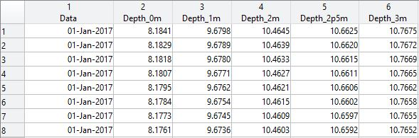

<S6> PT2Z_6_Temp_To_DepthZ_Figure

Figure.11) Section 6 of PT2Z_1 Master Script. This section requires 2 inputs [lines 169 and 171].

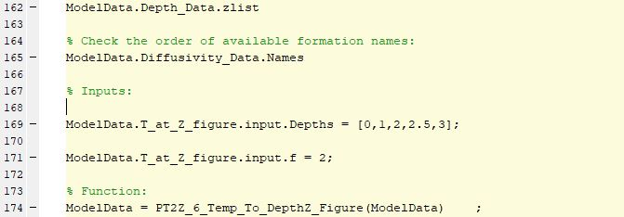

<S6> requires lines [169 & 171] be defined and generates a plot of t vs z for the depths specified by the user (figure.12). This allows a comparison of temperature through time at depths of interest.

<S6>, [line 169] is the depths you want to compare. These must coincide with the depth range defined in <S4>, to check the available depths, run [line 162].

<S6> [line 171] is the diffusivity you want to generate a plot for. The number is the order in which they are entered in <S4>. To check, run line 165.

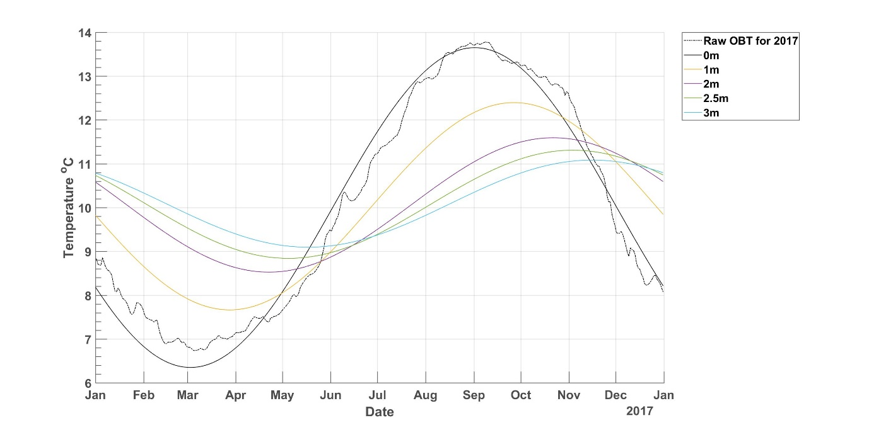

Figure.12) The output figure to <S6> demonstrates the effect of propagating the idealised input (OBT) to depths through mediums of diffusivities defined by the user. This shows the amplitude of temperature perturbation decreases with depth and is increasingly phase shifted to the right. (figure.12) is saved automatically with a name e.g. “PT2Z_6_OBT_2017_Forth_Sand_0m_to_3m.jpeg” in the figures folder. If there’s an ambient OBT and the flag on [line 116] = 1 the raw OBT will be plotted on top of the idealised sinusoid or 0m line.

<S7> PT2Z_temp_vs_Depth_at_times_t_Figure

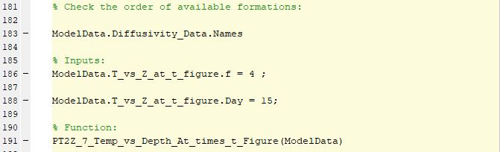

Figure.13) Section 7 of the PT2Z_1 Master script. <S7> requires 2 inputs on [line 186 & 188]. This section outputs a Z vs T figure for the same day of each month (figure.14).

<S7> Requires 2 inputs and plots Z vs t figure at the same day of each month for the formations provided.

<S7> [lines 186] defines the diffusivity / formation name, in the order they are defined in <S4>. You can check this by running [line 183].

<S7> [line 188] defines the day you want to extract, 1 or 15 is the best and its more there for clarity so the user knows exactly what data is been plotted.

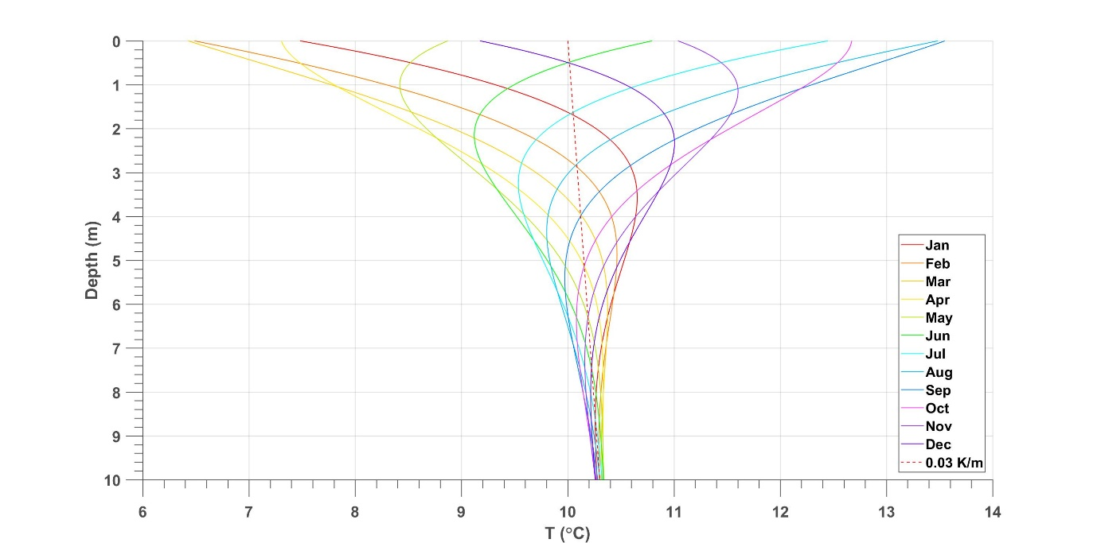

Figure.14) The output figure to <S7>. For the example provided (figure.13) Z is plotted against T for the 15th of each month. The geotherm defined in <S4> is also plotted. This demonstrates the amplitude seasonal temperature perturbations with depth and the effect of the geotherm which is defined in <S4>. The residual of the (OBT) variation can be seen to decrease with depth, at ~10m the seasonal variation is approximately constant, this will be less true with increasing thermal diffusivity. (figure.14) is automatically saved to the figures folder as e.g.” PT2Z_7_OBT_2017_Monthly_Extrap_through_Wee_Bankie_Mud_0m_to_10m”

References:

1. Carslaw, H. S., and J. C. Jaeger (1959), Conduction ofHeat in Solids, 2nd ed., 510 pp., Oxford Univ. Press, New York.
2. Hamamoto, H., Yamano, M., & Goto, S. (2005). Heat flow measurement in shallow seas through long-term temperature monitoring. *Geophysical Research Letters*, *32*(21), 1–5. https://doi.org/10.1029/2005GL024138
3. HILLEL, D. (1982). Soil Temperature and Heat Flow. *Introduction to Soil Physics*, pp. 155–175. https://doi.org/10.1016/b978-0-08-091869-3.50013-5
4. Lee, T. C., & Cohen, L. H. (1979). Onshore and offshore measurements of temperature gradients in the Salton Sea geothermal area, California. *Geophysics*, *44*(2), 206–215. https://doi.org/10.1190/1.1440962
5. Miesner, F., Lechleiter, A., & Müller, C. (2015). Reconstructing bottom water temperatures from measurements of temperature and thermal diffusivity in marine sediments. *Ocean Science*, *11*(4), 559–571. https://doi.org/10.5194/os-11-559-2015
6. Müller, C., Usbeck, R., & Miesner, F. (2016). Temperatures in shallow marine sediments: Influence of thermal properties, seasonal forcing, and man-made heat sources. *Applied Thermal Engineering*, *108*, 20–29. <https://doi.org/10.1016/j.applthermaleng.2016.07.105>
7. Worzyk, T. (2013). *Submarine Power Cables*. 1st ed. Berlin: Springer Berlin.